**Process Flow Diagram**

Process Flow Diagram or Flowchart is a diagram which uses geometric symbols and arrows to define the relationships. It is a diagrammatic representation of the algorithm. The Process flow Diagram of our application is shown below.

Its purpose is to present a graphical overview of the functionality provided by a system in terms of actors and their goals.The main purpose of a use case diagram is to show what system functions are performed for which actors.

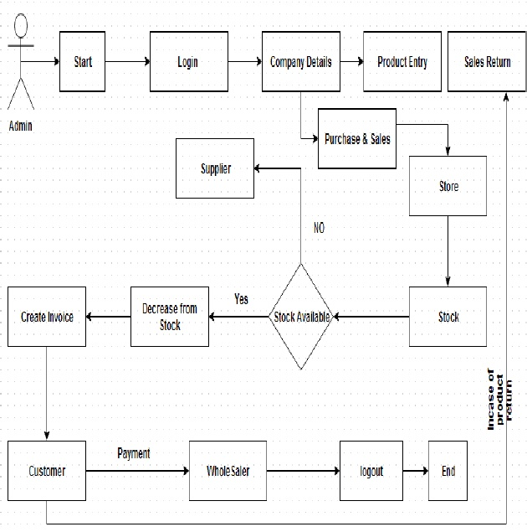

**Diagram Building Block Use cases**

A use case describes a sequence of actions that provide something of measurable value to an actor and is drawn as a horizontal ellipse.

**Actor**

An actor is a person, organization or external system that plays a role in one or more interactions with the system

**System boundary boxes (optional)**

A rectangle is drawn around the use case called the system boundary box to indicate scope of the system.

**Use case**

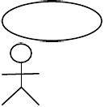

**Actor**

**IMS Use Case Diagram:**

